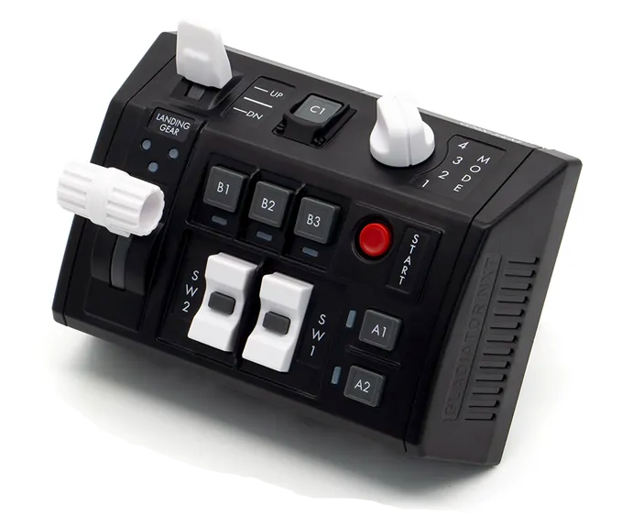
GNX SEM-V button numbers
U=Up, D=Down, N=Neutral, F=Forward, B=Backward, L=Left, R=Right, P=Press, S-*=Shift-*, L-*=Long-*

Landing Gear lever
- U: Button 21
- N: Button 19
- D: Button 18
Flaps Switch
- U: Button 24
- N: Button 23
- D: Button 22
SW1 Rocker Switch
- U: Button 6
- P: Button 7
- D: Button 8
SW2 Rocker Switch
- U: Button 9
- P: Button 10
- D: Button 11
Start Button
- P: Button 12
A1 Button
- P: Button 1
A2 Button
- P: Button 2
B1 Button
- P: Button 3
B2 Button
- P: Button 4
B3 Button
- P: Button 5
C1 Button
- P: Button 17
Mode Knob
- 1: Button 13
- 2: Button 14
- 3: Button 15
- 4: Button 16

